**Sustrans Bike It Plus in Salisbury**

Robin.Imeson@sustrans.org.uk

07818 522991

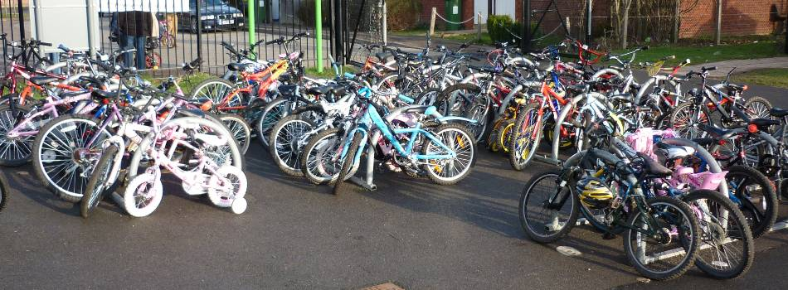

**Case Study: Bemerton St John Primary School** became a Bike it Plus school in October 2014.

**Results**

Before the project launched the travel habits of the pupils were surveyed. The results showed that 4 pupils currently cycle regularly, which equals 2%, the same as the national average. However 108 pupils want to cycle regularly, which equals 53.5%, which is 5.5% higher than the national average. In all 168 pupils want to travel actively (83%) and my job is to empower and enable them to do so!

**Events**

Bemerton St John have already had a ‘Be Safe, Be Seen’ non-uniform day, where they learnt about the importance of lights and reflective strips when they’re travelling actively at night or in the dark winter months. They are looking forward to some smoothie bike workshops in Jan and the launch of the ‘Golden Lock’ incentive scheme. They also have a Bike It Breakfast planned where anyone travelling to school actively gets a free breakfast!

**What?**

 Bike It Plus is an exciting project from Sustrans, the UK’s leading sustainable transport charity. We work with schools to encourage safe cycling, scooting and walking to school. We aim to reduce the number of cars outside the school gates and make active travel a safe and achievable option.

**Why?**

 Bike It Plus is funded by Public Health at Wiltshire Council to tackle childhood obesity and inactivity by encouraging everyday exercise i.e. the school journey.

Active travel is a great way for children to keep healthy, gain some independence and have fun getting to and from school. There is also evidence linking physical activity with educational attainment.

**How?**

 Our local officer works with a key member of staff and group of pupils to develop a program of events and activities tailored to the needs and interests of each school.

**Where?**

 Sustrans delivers projects with children and young people all over the country, including Salisbury and the rest of Wiltshire.



Sustrans is the charity that’s enabling people to travel by foot, bike or public transport for more of the journeys we make every day. It’s time we all began making smarter travel choices. Make your move and support Sustrans today. www.sustrans.org.uk

© Sustrans 2012. Registered Charity No. 326550 (England and Wales) SCO39263 (Scotland)

